## County Hall Beverley East Riding of Yorkshire HU17 9BA www.eastriding.gov.uk

Councillor Richard Burton Leader of the Council

Dear residents, businesses and local communities

**Preventing the spread of COVID-19 and** **saving East Riding lives: It’s in our hands!**

Back in March, a week before we went into a national lockdown, I wrote an open letter to the East Riding to assure you all that East Riding of Yorkshire Council would do all it possibly could to support local communities through the COVID-19 pandemic.

Throughout the lockdown period, we continued to collect and empty 50,000 bins a day, we provided vital care and support to our most frail, elderly, poorly and vulnerable residents, we quickly processed tens of millions of pounds-worth of grants and other payments to thousands of businesses and we operated community response hubs with the HEY Smile Foundation and other partners – helping those in need with deliveries of food, medication and other support.

There were countless other ways the council and its staff helped local residents, businesses and communities through the first wave of COVID-19 and we have continued to support the East Riding as the Government eased lockdown measures in the summer.

The East Riding has fared better than many other areas, with generally much lower infection rates, hospital admissions and loss of life.  However, every loss has of course been a personal tragedy to those affected and every hardship suffered by residents – whether bereavement, physical or mental illness, financial, social or emotional – is a cause for sorrow and regret. That is why I am now writing another open letter to the East Riding, to urge everyone to play your part in helping to avoid more loss and hardship.

Infection rates are still lower in the East Riding than many places elsewhere but they are rising quickly and if we don’t all act now, to take individual and collective action, then we will all suffer the consequences in the weeks and months to come.

We are at a crucial time in the fight against COVID-19. The next few weeks are going to be pivotal in determining what happens with COVID-19 in the East Riding this autumn and winter.

Therefore the time is NOW to act by doing the right thing when it comes to COVID-19 prevention.

Please keep following the **3 Steps To Safety: Prevent. Notice. Act.** Keep doing the basic things which we know helps to prevent the spread of this virus – handwashing, social distancing, wearing a face covering where appropriate and if you’re not exempt, quickly responding to symptoms by getting tested and self-isolated if advised to.  Nationally, a staggering 80% of people are failing to self-isolate when they should be.

**It’s really simple. If you have any COVID-19 symptoms, if you have been tested but are waiting for the result or if you have tested positive, do NOT go out. Stay at home. Self-isolate. Do not mix with other people from outside your household.**

We are entering a new phase in this pandemic, with more incidences of it spreading and neighbouring areas seeing major increases. The next few weeks could see a surge in numbers and we will only avoid that if all residents work together by doing those basic things but most essentially by isolating themselves when they have symptoms, have tested positive or are awaiting a test result.

I’m afraid we all need to make some personal sacrifices right now, in various aspects of our daily life, if we are to keep the East Riding as a safe place to live, work, shop, learn, play, invest and visit.

We need to do the right thing now to protect our most vulnerable residents – the people we love and cherish. Our vulnerable family members, friends, colleagues and neighbours.

At this time of year, people are normally starting to look forward to Christmas. This year Christmas will be very different if we don’t all act now by doing the right thing.  All of us need to reduce our individual risk so that we are reducing the risk to our loved ones and the whole of the East Riding – local communities, local businesses and local people.

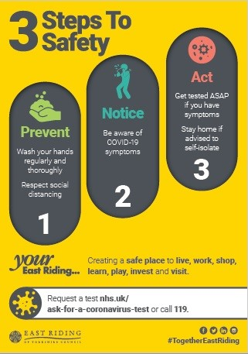

We have shown throughout the spring and the summer that the #TogetherEastRiding is strong and we need that to continue more than ever.

For those people who are ignoring the risks, who are going out even though you have symptoms or are waiting for test results, who are forgetting to do the basics right, please stop and think about what you are doing and the consequences your actions will bring for us all.

Please follow the 3 Steps To Safety, for your own health, for the sake of your loved ones and for everyone in the East Riding.  We all want to avoid another lockdown unless absolutely necessary, we all want to avoid more hardship and we all want to avoid more loss of life and personal tragedies.

Our future is in our hands. Please do the right thing. Now.

On behalf of everyone at East Riding of Yorkshire Council, thank you for your support and stay safe.



Cllr Richard Burton   
Leader, East Riding of Yorkshire Council